VPrivCal
  - A Brief Preference-Elicitation and Awareness-Confirmation Method for User-Aligned Privacy Reminders in Vision-Language Assistants
Updated full research plan for egocentric VLM scenarios
Decision / research question
Can a brief calibration produce a personalized privacy-reminder policy that better matches an individual user’s preferences in unseen egocentric video interactions than a generic policy?

Method at a glance
Element | Current design
Overall method | One rapid calibration method with two components: VPrivCal-Q10 and VPrivCal-Probe.
Component 1 | VPrivCal-Q10 initializes category and reminder-policy defaults.
Component 2 | VPrivCal-Probe uses three egocentric scenes spanning private, public, and semi-public settings. Participants point to noticed content, then review every predefined category present in each scene.
Output | A transparent, user-specific privacy-reminder policy.
Primary evaluation | Generic policy versus Q10-only policy versus full VPrivCal on held-out egocentric videos.
Primary outcomes | Preference alignment, over-reminding, under-protection, severe under-protection, burden, and user-friendliness.

Version 6.0 | July 2026 | Unified naming: VPrivCal-Q10 + VPrivCal-Probe

1. Executive summary
VPrivCal is a brief cold-start calibration method for egocentric VLM assistants, including wearable-camera and AI-glasses scenarios. It is intentionally narrower than a general visual-privacy taxonomy or a full consent-management system. The method first asks ten direct policy questions, then uses three egocentric scenes spanning private, public, and semi-public settings. Participants point to privacy-sensitive content they noticed before the system reveals detections, and then answer awareness and preferred-action questions for every predefined privacy category present in each scene.
The calibration itself is not the effectiveness outcome. Its value is tested on held-out egocentric video cues. The principal claim is therefore conditional: VPrivCal is effective only if the resulting policy better predicts the same participant’s later desired actions, reduces unnecessary reminders, and does not increase under-protection.
Scope boundary
The first study concerns user-facing privacy reminders and pre-use intervention decisions in egocentric visual assistance. Long-term memory, external sharing, and delegated actions are excluded unless a later system version implements those behaviors.

2. Unified method architecture
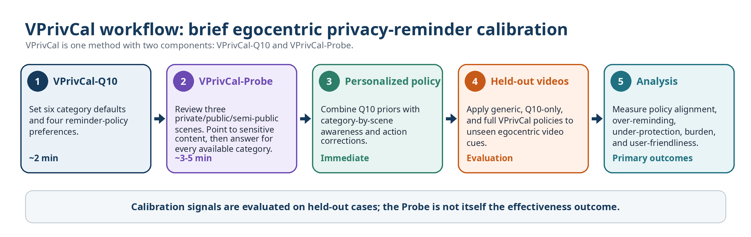
Figure 1. VPrivCal workflow. The two components belong to one method; policy effectiveness is assessed only on held-out video cases.
Component | Role | Signal
VPrivCal-Q10 | Rapid preference initialization | Six category defaults plus four reminder-policy settings.
VPrivCal-Probe | Contextual awareness confirmation and correction | For every available category-image pair: prior awareness status and preferred future action, linked to one or more detected regions.
Policy layer | Transparent personalization | Category priors are updated by contextual category-level corrections and scene type.
Held-out evaluation | Effectiveness test | Compare policy actions with the participant’s desired actions on new videos.

3. Research questions and hypotheses
ID | Research question / hypothesis
RQ1 | Can VPrivCal-Q10 predict desired reminder actions for unseen egocentric video cues?
RQ2 | Does full VPrivCal (Q10 + Probe) improve held-out action alignment over a generic policy and a Q10-only policy?
RQ3 | Does full VPrivCal reduce over-reminding without increasing under-protection or severe under-protection?
RQ4 | Which visual categories and awareness-gap types transfer most reliably from static calibration images to dynamic video?
H1 | Full VPrivCal will yield lower ordinal action error than the generic and Q10-only policies.
H2 | Full VPrivCal will reduce unnecessary reminders while preserving protection for high-severity cues.
H3 | Participants will report higher reminder relevance and perceived control for full VPrivCal.

4. VPrivCal-Q10: rapid preference initialization
Q1-Q6 retain the six high-level visual privacy categories used in the project. To reduce repetition and leading wording, the system presents one shared question and response scale, then shows the six categories one by one.
Shared question for Q1-Q6
When this type of information appears in an egocentric image or video, what should the assistant do by default?
1 Use for the current task without interruption | 2 Handle silently and avoid unnecessary detail | 3 Give a brief reminder | 4 Ask before using it | 5 Do not use it unless explicitly requested

Item | Category | Examples | Policy parameter
Q1 | Biometric data | Faces, fingerprints, and other distinctive body features that may identify a person. | biometric_data_action
Q2 | Children images | Children, school events, playgrounds, and child-related activities. | children_images_action
Q3 | Personally identifiable information (PII) | Financial or medical data; names, passports, email addresses, phone numbers, GPS, license plates, and other identifiers. | pii_action
Q4 | Legal sensitivity information | Nudity or explicit imagery; violent or unlawful acts; criminal acts; weapons or other high-risk items. | legal_sensitivity_action
Q5 | Personal life | Home interiors, personal items, location context, landmarks, routines, relationships, and activities. | personal_life_action
Q6 | Background individuals | Passersby, bystanders, coworkers, patients, patrons, and other people incidentally captured. | background_individuals_action

4.1 Cross-cutting reminder-policy questions
Item | Dimension | Direct policy question | Parameter
Q7 | Inferred risks | When a visual cue supports a sensitive inference, should the system ignore it, remind only for likely/serious cases, give a brief reminder, ask first, or avoid the inference unless requested? | inference_reminder_level
Q8 | Reminder sensitivity | Should the system show very few reminders, serious/likely reminders only, balance misses and false alarms, show most plausible risks, or show every possible risk? | reminder_sensitivity
Q9 | Uncertainty | When sensitivity is uncertain, should the system do nothing, show a quiet indicator, give a brief uncertain reminder, ask first, or avoid using the information until approved? | uncertain_risk_action
Q10 | Task relevance | When sensitive content is visible but not needed for the task, should the system do nothing, remind only if serious, show a brief indicator, ask first, or avoid it unless requested? | task_irrelevant_action

Timing target
The engineering target is a median completion time of about two minutes for Q10. Pilot readiness should require a median below three minutes, fewer than 5% skipped items, and no recurring comprehension error.

5. VPrivCal-Probe: three-scene, category-complete calibration
The revised Probe removes the active baseline VLM task and does not restrict each image to two cues. Each scene begins with an unmarked image. Participants first click or tap any specific content they think the assistant should handle carefully. The interface maps the selected region to one or more researcher-verified detections and automatically proposes a category, which the participant can correct. After this unprompted pointing phase, the system reviews every predefined high-level category present in that scene, highlights the linked evidence, and asks two compact questions. This design preserves an initial awareness signal while achieving complete category coverage across the three scenarios.
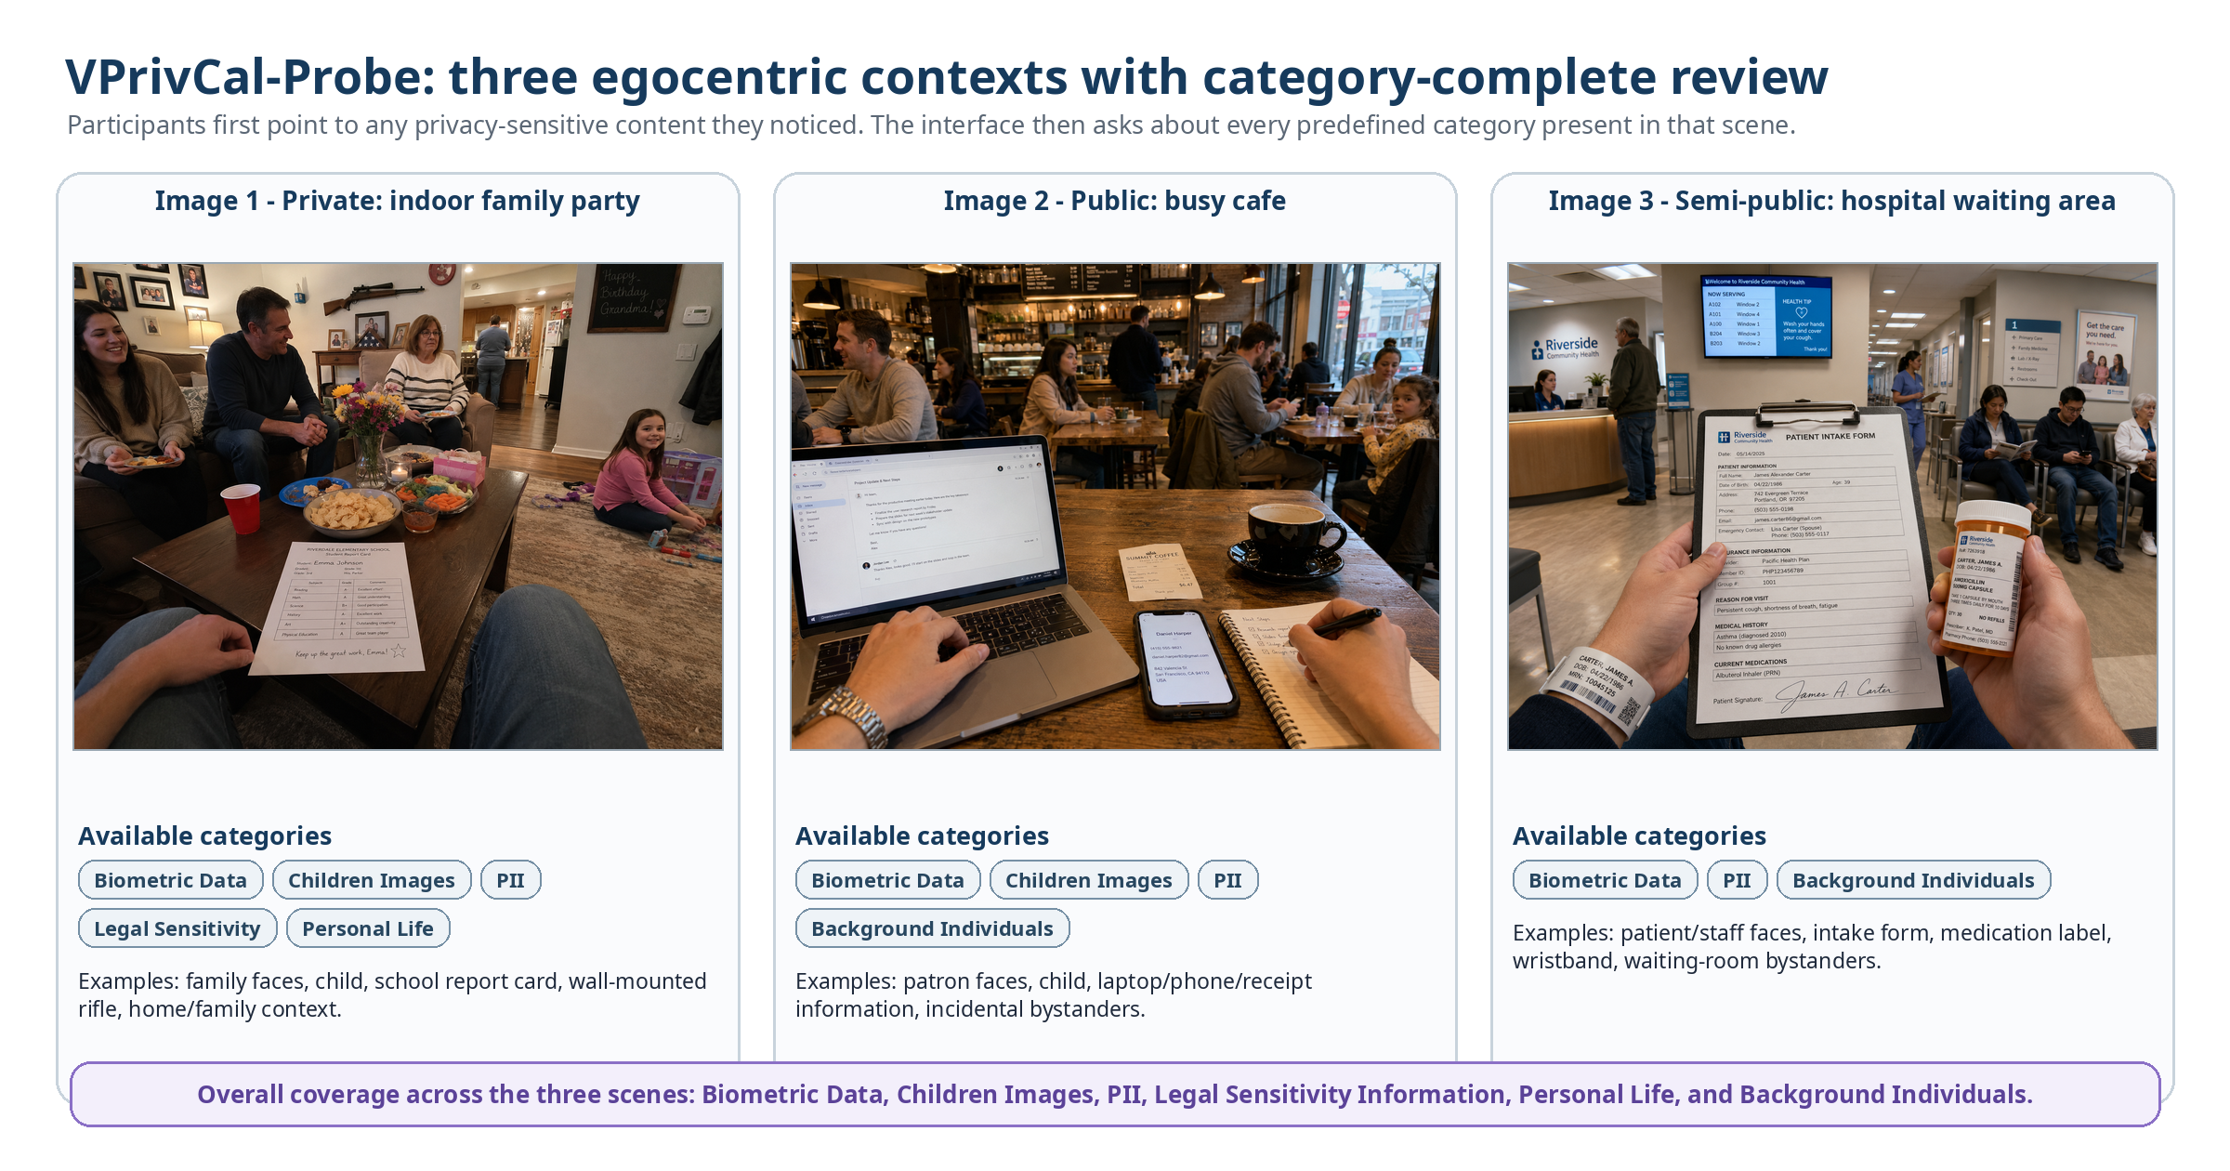
Figure 2. Revised VPrivCal-Probe stimuli. The set spans a private home party, a public cafe, and a semi-public hospital waiting area. Participants review all categories available in each scene; together, the three images cover all six high-level visual privacy categories.

5.1 Scenario coverage and category completeness
Scene | Scenario context | Available high-level categories | Representative evidence
1. Private - indoor family party | A first-person view during a family birthday gathering inside a home. | Biometric Data; Children Images; PII; Legal Sensitivity Information; Personal Life. | Family faces, an identifiable child, a school report card, a wall-mounted rifle, family photographs, toys, and home/family context.
2. Public - busy cafe | A first-person view while using a laptop and writing notes in a crowded cafe. | Biometric Data; Children Images; PII; Background Individuals. | Patron faces, a child, visible laptop email, phone contact details, a receipt, and incidental cafe bystanders.
3. Semi-public - hospital waiting area | A first-person view while holding medical documents in a hospital waiting area. | Biometric Data; PII; Background Individuals. | Patient and staff faces, an intake form, prescription label, patient wristband, and waiting-room bystanders.

5.2 Point-first, reveal-second interaction
The image is initially shown without overlays. A participant may click multiple regions. The interface converts each click to normalized image coordinates, matches it against the detection file, selects the smallest valid overlapping region, and proposes the detection’s primary category. Participants can change the category, delete a selection, or draw a manual region when no detection matches. Only after the participant submits this first pass does the interface reveal the scene’s complete category list and category-linked evidence. This avoids using the VLM detections to prime the initial search while still ensuring that every available category is evaluated.
Phase | Participant view | System behavior | Recorded signal
A. Unprompted pointing | Clean image without boxes or category labels. | Hit-test clicks against normalized detection boxes; propose a category but allow correction. | Clicked coordinates, matched detection IDs, spontaneous category selections, corrections, and unmatched manual regions.
B. Category-complete review | All predefined categories present in the scene, one card at a time. | Highlight all evidence linked to the active category only after the participant opens the card. | Awareness status and preferred action for each category-image pair.
C. Policy update | Concise summary of category defaults and contextual corrections. | Combine Q10 priors with Probe responses while retaining scene type. | Personalized intervention level by category and contextual exceptions.
D. Export | Completion summary. | Save a de-identified JSON record for later analysis. | Timing, click mapping, category corrections, awareness, actions, and profile confirmation.

5.3 Two questions per category-image pair
Question A: awareness status
Before the content supporting this category was highlighted, which best describes your experience?
1 Already noticed it and considered the privacy implication.
2 Noticed it but had not considered the privacy implication.
3 Had not noticed it, or did not realize the VLM could detect or infer it.
4 I do not consider it a privacy concern in this situation.

Question B: preferred action
When similar content in this category appears in the future, what should the assistant do?
1 No intervention.
2 Handle it silently.
3 Give a brief reminder.
4 Ask before using it.
5 Avoid using it unless I explicitly request it.

Response to Question A | Interpretation
1 | Already privacy-aware.
2 | Interpretive gap: the cue was perceived, but its privacy implication was not considered.
3 | Perceptual or capability gap: the cue was not noticed, or the participant did not realize the VLM could detect/infer it.
4 | Rejected cue: valid content may exist, but the participant does not regard it as a privacy concern in context.

Critical interpretation rule
An awareness gap does not automatically imply a reminder need. Question A characterizes awareness; Question B determines the desired intervention and is the primary signal used to update the policy.

6. Personalized policy construction
The base VLM supplies candidate detections, while a transparent policy layer decides whether to suppress, handle silently, remind, ask, or avoid. The study should not fine-tune the VLM from the small number of category-by-scene judgments. The purpose is to test whether the elicited signals are actionable and generalize to held-out video cases.
Action level | Label | System behavior
0 | No intervention | Do not surface a reminder.
1 | Silent handling | Use only as needed without interrupting or mentioning unnecessary detail.
2 | Brief reminder | Show a concise, non-blocking privacy notice.
3 | Ask first | Request confirmation before using the cue in the response.
4 | Avoid unless requested | Exclude the cue or inference until the user explicitly requests it.

Recommended proof-of-concept update rule: initialize each category from VPrivCal-Q10; treat each Probe category-image response as one contextual observation; combine the prior and contextual responses using a transparent weighted median or rounded weighted mean. The Probe response may override the questionnaire for the corresponding category, while retaining the scene type as contextual metadata.
Recommended conservative guardrail: personalization may suppress low-severity reminders, but it should not suppress a hard safety floor for children, bystanders, or high-confidence severe risks until the project has explicitly justified such personalization.

7. Held-out egocentric video evaluation
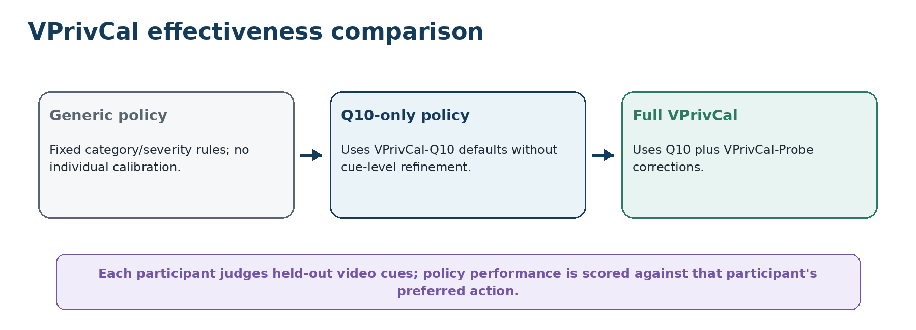
Figure 3. Policy conditions tested on held-out video cues.
Static image calibration and dynamic video evaluation are intentionally different. The study tests whether sparse preferences elicited from still scenes transfer to continuous egocentric perception. Held-out clips should include at least some video-specific cues: brief exposure, entering/leaving bystanders, repeated views, cross-frame accumulation, or cues that become sensitive only through temporal context.
Design element | Recommendation
Participants | N = 80-120 for the main controlled study; use a smaller N = 12-20 usability pilot first.
Design | Within-subject policy evaluation with clip-policy assignment counterbalanced by Latin square.
Materials | 10-12 short egocentric clips, approximately 10-25 seconds each, with 1-2 candidate cues per clip.
Policies | Generic baseline, VPrivCal-Q10 only, and full VPrivCal.
Cue balance | At least two held-out manifestations per high-level category; include direct, subtle, and temporally emerging cases.
Controls | Include a small number of ambiguous or invalid detections to estimate suggestion acceptance.
Model output | Pre-generate detections with one fixed VLM and settings; expert-screen cue descriptions before the study.

7.1 Questions participants answer for each held-out cue
Construct | Question | Response
Detection validity | Is the described cue actually visible or reasonably supported by the video? | Yes clearly / Partly / No / Unsure
Personal privacy relevance | How privacy-relevant is this cue to you in this situation? | 1 Not relevant - 5 Extremely relevant
Preferred action | What should the assistant do? | No intervention / Silent / Brief reminder / Ask first / Avoid
Shown-action appropriateness | How appropriate was the action shown by this policy? | 1 Very inappropriate - 5 Very appropriate
Optional rationale | What should have been different? | Short text

Why detection acceptance is secondary
A participant may agree that a cue exists but still reject a reminder. Detection validity, privacy relevance, and desired action must therefore be analyzed separately.

8. Outcomes and metrics
Metric | Operational definition | Role
Exact policy alignment | System action exactly equals participant-preferred action. | Primary
Ordinal action error | Mean absolute distance between system and preferred action levels. | Primary
Over-reminder rate | System action is reminder/ask/avoid while user prefers no intervention or silent handling. | Primary burden guardrail
Under-protection rate | System action is less protective than the user-preferred action. | Primary privacy guardrail
Severe under-protection | Under-protection for cues rated 4-5 in privacy relevance or preclassified as high consequence. | Safety outcome
Reminder acceptance | Participant rates the displayed intervention as appropriate. | Secondary
Probe awareness profile | Already aware / interpretive gap / perceptual-capability gap / rejected cue. | Descriptive
Awareness-to-intervention conversion | Gap cues for which the participant requests reminder, ask, or avoid. | Mechanism metric
Calibration burden | Completion time, skipped items, changes, perceived effort. | Feasibility
User-friendliness | Relevance, appropriateness of number/timing, interruption, protection, control, willingness to use. | Subjective outcome

8.1 Post-policy user-friendliness items
- The reminders focused on privacy risks that were relevant to me.
- The number of reminders was appropriate.
- The reminders appeared at appropriate moments.
- The reminders interrupted the main task more than necessary.
- The system made me feel sufficiently protected.
- I felt in control of how the assistant handled privacy risks.
- I would use this reminder configuration in a real egocentric assistant.
Use a 7-point agreement scale. Analyze relevance, burden, protection/control, and adoption separately unless psychometric evidence supports a composite.

9. Statistical analysis
- Exact alignment: logistic mixed-effects model with policy condition as a fixed effect and participant, clip, and cue as random intercepts.
- Ordinal error and preferred action: cumulative-link mixed model or linear mixed model after checking distributional fit.
- Over-reminding and under-protection: mixed-effects logistic models; pre-register full VPrivCal versus generic as the primary contrast.
- Subjective scales: paired or mixed-effects comparisons across policies; report confidence intervals and effect sizes.
- Category transfer: interactions between condition and privacy category, salience, direct versus inferred cue, and temporal dependence.
- Robustness: exclude invalid cues, exclude unsure responses, vary severity threshold, and repeat analyses with weighted under-protection costs.

10. Pilot gates and expert screening criteria
Area | Minimum gate before main study
Q10 comprehension | At least 80% of cognitive-interview participants paraphrase each item consistently.
Q10 timing | Median <= 3 minutes; fewer than 5% skipped core items.
Probe timing | Median <= 5 minutes for the complete pointing and category-review phase; median total calibration time <= 7 minutes. Re-estimate after the usability pilot rather than assuming a three-minute total.
Stimulus distinctiveness | Experts and users distinguish the private, public, and semi-public settings and understand why the same category may appear in multiple scenes.
Category and evidence validity | At least 80% accept each listed category as present in its scene and each linked detection as valid supporting evidence; disputed items are revised or removed.
Pointing and mapping usability | At least 90% of intended selections are matched to a detection or successfully corrected through the manual-region/category controls; detections remain hidden before submission.
Safety | No unresolved critical issue involving bystanders, children, false sensitive inferences, or severe under-protection.

11. Ethics, data management, and limitations
- Use only synthetic or fully consented egocentric stimuli; never expose real identifiers or real sensitive records.
- Do not ask the model to infer actual protected traits about identifiable real people. Use synthetic cues and categorical descriptions.
- Allow participants to skip high-risk content and explain that the calibration cannot guarantee privacy.
- Store only de-identified responses; keep image/video files separate from participant identifiers.
- The three-scene Probe provides retrospective and interaction-based awareness evidence, but it still cannot establish spontaneous awareness during unconstrained natural use.
- The initial results generalize to egocentric assistance, not automatically to uploaded photos, screenshots, or social-media images.

12. Recommended execution sequence
Phase | Participants | Purpose
Expert screen | 6-10 experts | Review content validity, cue coverage, action semantics, safety, and study feasibility.
Cognitive interviews | 6-10 target users | Check interpretation of Q10, probe responses, and policy labels.
Usability pilot | 12-20 users | Measure timing, confusion, scene salience, and workflow failures.
Main evaluation | 80-120 users | Compare generic, Q10-only, and full VPrivCal on held-out videos.
External validation | Optional | Repeat on a new video set, user population, or VLM.

13. References
Tsaprazlis, E., Feng, T., Ramakrishna, A., Gupta, R., & Narayanan, S. (2025). Assessing Visual Privacy Risks in Multimodal AI: A Novel Taxonomy-Grounded Evaluation of Vision-Language Models. arXiv:2509.23827.
Orekondy, T., Schiele, B., & Fritz, M. (2017). Towards a Visual Privacy Advisor: Understanding and Predicting Privacy Risks in Images. ICCV.
Tomekce, B., Vero, M., Staab, R., & Vechev, M. (2025). Private Attribute Inference from Images with Vision-Language Models. NeurIPS.
Amershi, S., et al. (2019). Guidelines for Human-AI Interaction. CHI.
Terwee, C. B., et al. (2018). COSMIN methodology for evaluating content validity. Quality of Life Research, 27, 1159-1170.
Polit, D. F., Beck, C. T., & Owen, S. V. (2007). Is the CVI an acceptable indicator of content validity? Research in Nursing & Health, 30(4), 459-467.

